**Project Design Phase-II Data Flow Diagram and User**

**Stories**

|  |  |
| --- | --- |
| Date | 17 November 2022 |
| Team ID | PNT2022TMID14625 |
| Project Name | Project - Smart Farmer-IoT Enabled Smart Farming Application |
| Maximum Marks | 4 Marks |

Data Flow Diagrams:

A Data flow diagram (DFD) is a common visual representation of how information moves through a system. A clean and understandable DFD can graphically represent the appropriate quantity of the system need. It displays how information enters and exits the system, what modifies the data, and where information is kept.

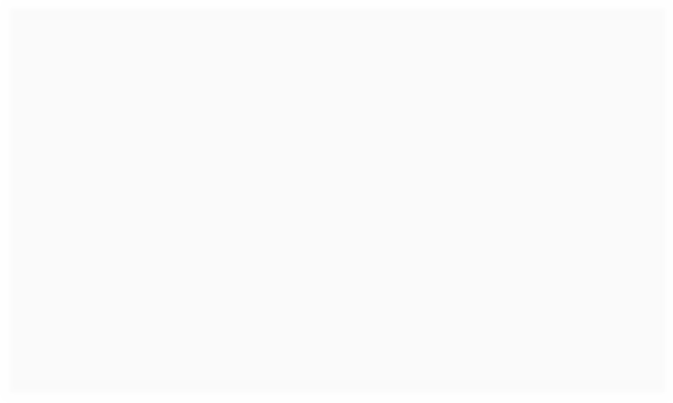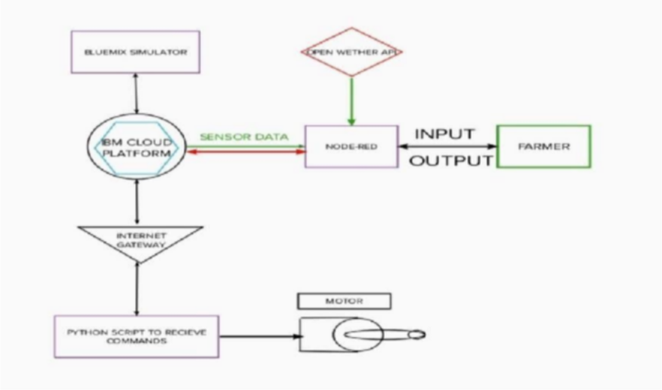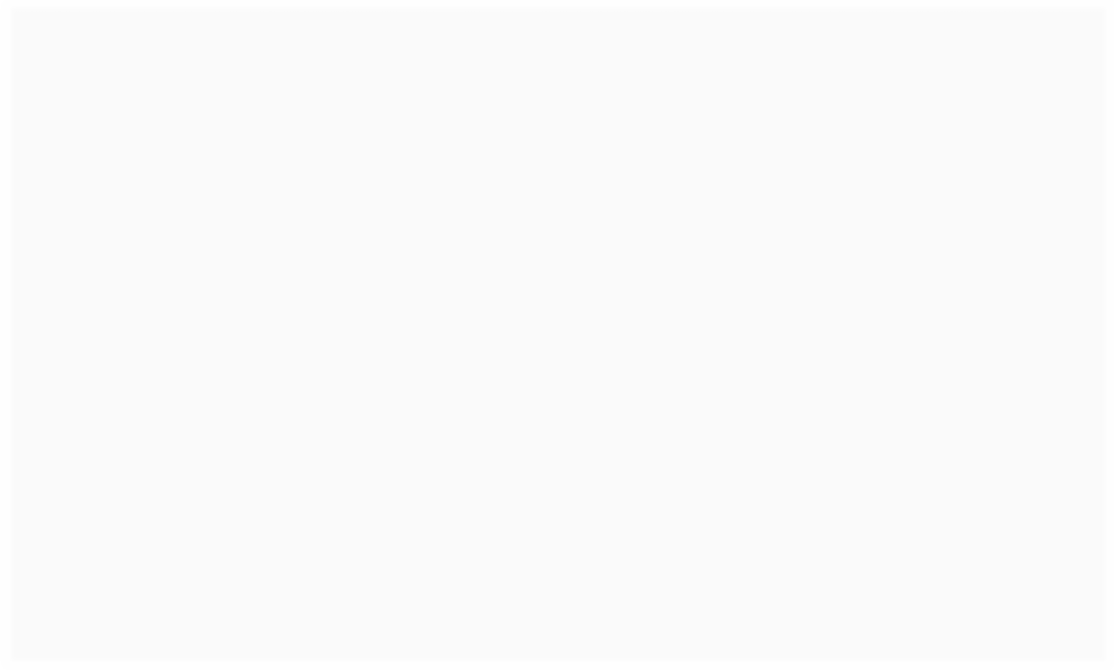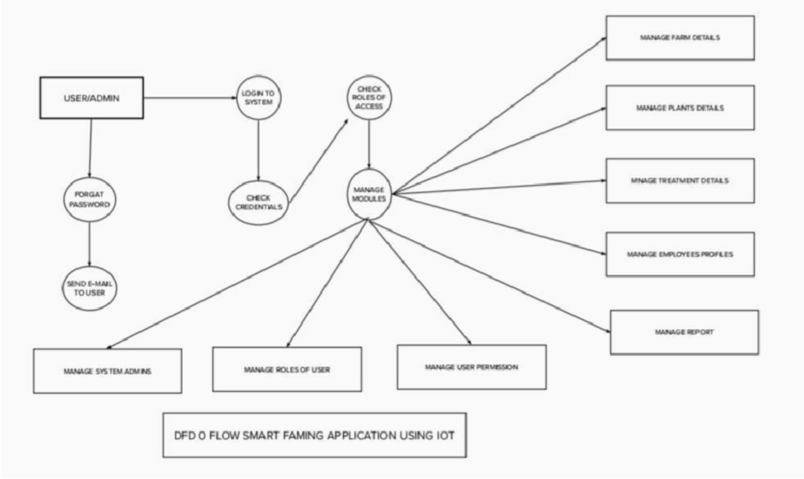

* Using various sensors, the various soil parameters, including temperature, moisture content and humidity are measured. The results are then stored in the IBM cloud.
* The Arduino UNO is utilised as a processing unit to process the data from the sensors and weather API.
* To write the hardware, software, and APIs. NODE-RED is employed as a programming tool. In order to communicate, the MQTT protocol is used.
* A mobile application created with MIT App Inventor makes all the collected data available to the user. Depending on the sensor results, the user might decide whether or not to irrigate the crop using an app. They can control the motor switch

remotely by utilising the app.

**User Stories**

|  |  |  |  |  |  |  |
| --- | --- | --- | --- | --- | --- | --- |
| **User Type** | **Functional**  **Requirement (Epic)** | **User Story Number** | **User Story / Task** | **Acceptance criteria** | **Priority** | **Release** |
| Customer (Mobile user) | Registration | 1 | Can register for the application by entering  my email, password, and confirming my password. | Can access my account  / dashboard | High | Sprint-1 |
|  |  | 2 | Will receive confirmation email once I have registered for the application | Receive confirmation email & click confirm | High | Sprint-1 |
|  |  | 3 | Can register for the application through Facebook | Can register & access  the dashboard with Facebook Login | Low | Sprint-2 |
|  |  | 4 | Can Register for the application through Gmail |  | Medium | Sprint-1 |
|  | Login | 5 | Can Log into the application by entering email & password |  | High | Sprint-1 |
|  | Dashboard |  |  |  |  |  |
| Customer (Web user) |  |  |  |  |  |  |
| Customer Care Executive |  |  |  |  |  |  |
| Administrator |  |  |  |  |  |  |